**WELCOME TO “THE BIRCHES” LAKESIDE SUITE**

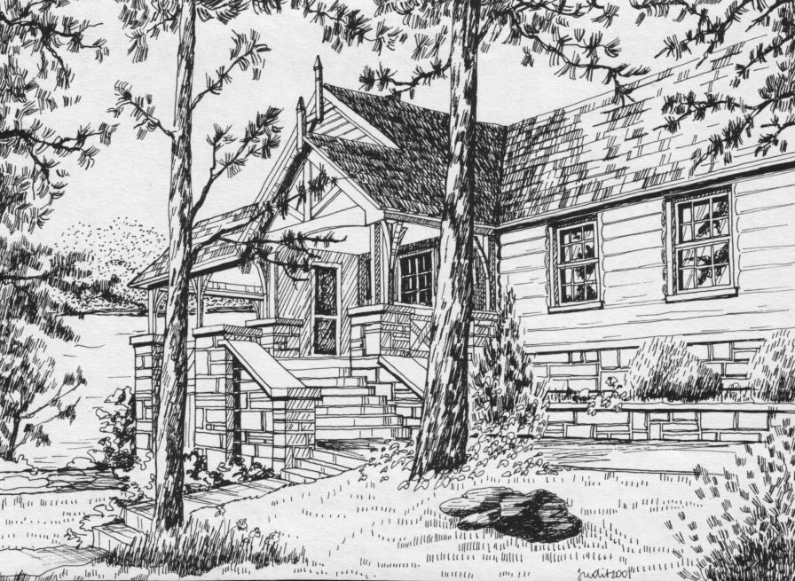

**CHATEAU WOODLAND LODGE – MAIN ENTRANCE**

**CHECK IN:** SUNDAY 3 PM

**CHECK OUT**: SATURDAY NOON

**ARRIVING:** At the Chateau Woodland sign on Kashagawigamog Lake Rd. turn onto our short entrance road. At the stop sign, turn left and park along the left side of the large parking lot.

**BIRCHES ENTRANCE**

From the parking lot, facing the lake & the Lodge, walk toward the right side of the Lodge

and follow the flagstone path around the perimeter of the Lodge. There will be a sign by the private entrance to your suite, marked TheBirches.

**ENTRY/KEYS/LOCKING UP**

There is an emergency key in the lockbox outside the entrance door. Use it to let yourself in and then replace it immediately. You’ll find a set of keys for daily use on the dining room table

**LOCKBOX INSTRUCTIONS**

1. Enter code - Birches is **\*\*\*\*\***(sent privately later)Press down on black button at top of cover.
2. Slide off cover...Remove key & unlock door. **Replace key immediatelyas this is an emergency key,**
3. To replace cover, repeat #1 &2 and slide cover on from bottom up,

**At the end of your stay, please leave the daily use keys on the table and the door locked using the lockbox key.**

**BEDS/BATH**

There is one double bed and 1 single bed in the bedroom and one double pullout facing the lake

in the living room. The suite has one full bathroom including a toilet, sink, shower/tub.

**BEDDING/TOWELS**

Please bring your own sheets, pillow cases, bath and dish towels..The duvet for the living

room is in the trunk.

**COOKING /GROCERIES**

In your suite, there is a toaster oven, range with oven, kettle, full-size fridge with freezer, coffee machine,

microwave, basic cooking utensils and place settings for 6.

There are two good Supermarkets in town: Foodland and The Independent.

Most restaurants are on the main street.

**WIFI:** The I.D. and password are posted on the bulletin board.

**WATER**

Our potable well water is treated with chlorine according to Ministry regulations and is tested every week. We have never had an adverse report.

**PLUMBING**

We live with a **Septic System** and this requires extra care when using water for any purpose.

Scrape plates and pans into the garbage. Do not scrape any food into the sink.

Wipe pots, pans and dishes free of oil and grease with a paper towel before washing

Absolutely NO tampons, paper towels, excess toilet paper, wads of paper or food down the toilet.

Any blockages will make your stay very unpleasant.

**GARBAGE**

There is a dumpster for garbage in the parking lot. Please ensure that the locking chain is secured to ward off visits from the bears! Please take your recycling home with you.

**CANDLES AND OPEN FLAMES**

Haliburtonis a high risk forest fire area. **Candles and open flames are strictly forbidden.**

**SMOKING**

Strictly **No Smoking**inside or near any buildings.

If you smoke outside in the open, please pick up your butts.

**PETS**

Pets are not allowed

.

**WIFI**

WIFI is available to you on the screened porch of the Lodge.(Access to the Lodge itself is formembers only.)_

You may also get a strong enough signal to use WIFI right in your suite.

Access codes are posted on the bulletin board

Many thanks for your co-operation and support. We hope you enjoy your stay.

*The Volunteers at Chateau Woodland*